

NOVAC TECHNOLOGY SOLUTIONS

User Manual

Document Version No.: 1.00

Revision History
Version No | Reason For Changes | Author | Approver
0.01 | Draft | Anurag Kumar
1.00 | Reviewed & Approved the User Manual | Anurag Kumar | NIJANTHAN PL

Table of Contents
1. Introduction 4

2. Claim Checklist Master Screen 4

Introduction

As per the requirement, System should have a Master screen to capture the Claim checklist details.
- Guidelines, circulars, instructions and directions released from time to time by Philippines Insurance council.

Claim Checklist Master Screen
- To incorporate a master screen for Claim checklist to capture the checklist details based on the Nature of Loss and the same should auto default in the claim checklist tab based on the selection of Nature of Loss for the respective product.

- Search the Claim checklist master screen in the main Menu
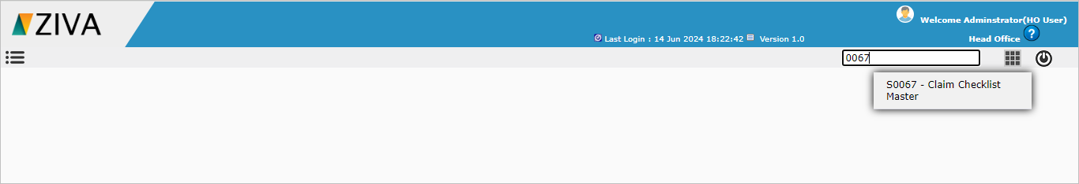

- Click on Claim checklist master screen. System will open the Claim checklist master dashboard.

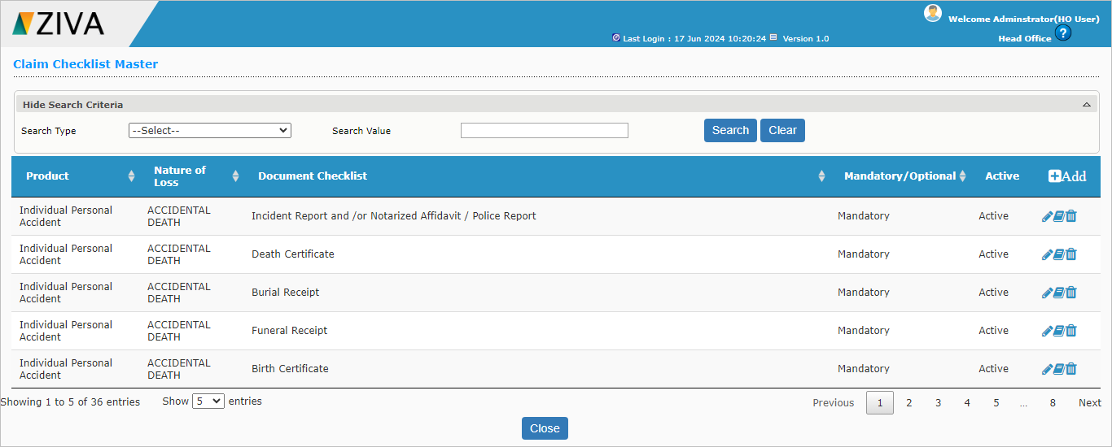

- Click on the Add button, Fill all the details and click on save button system will save the record.
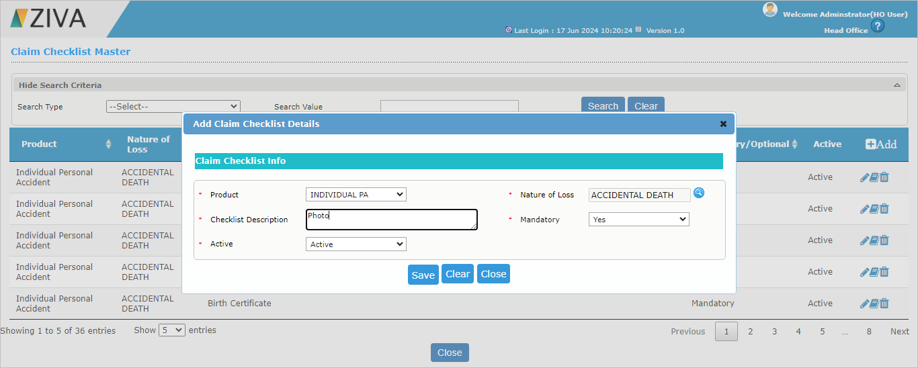

- Click on the Edit button to update the existing record
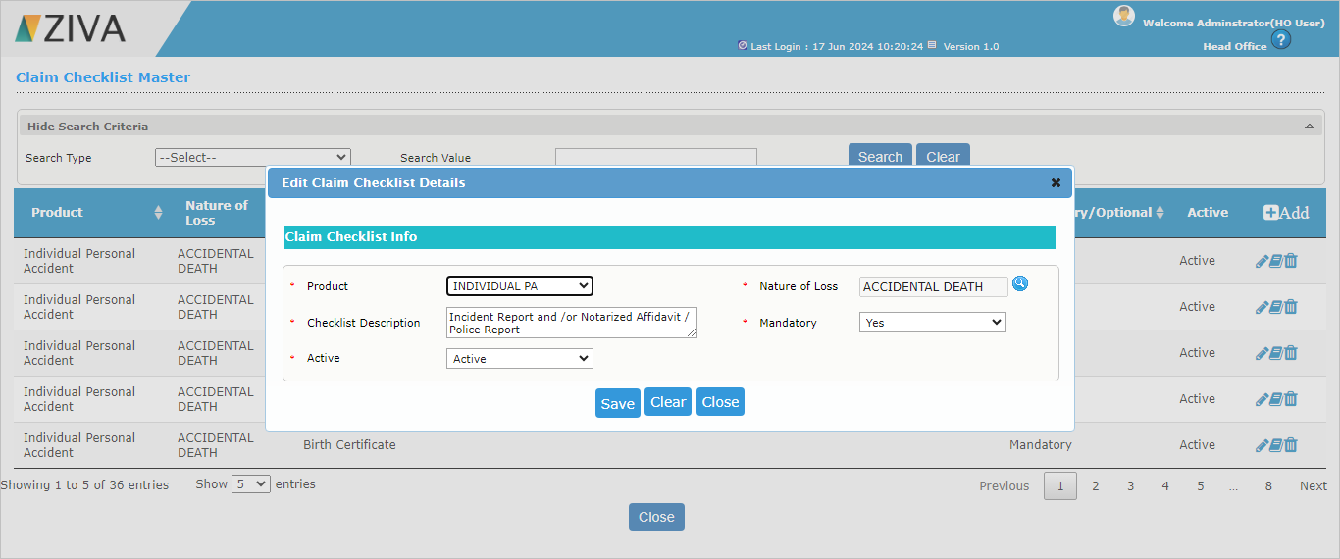

- Click on the View button to view the record from the dashboard.
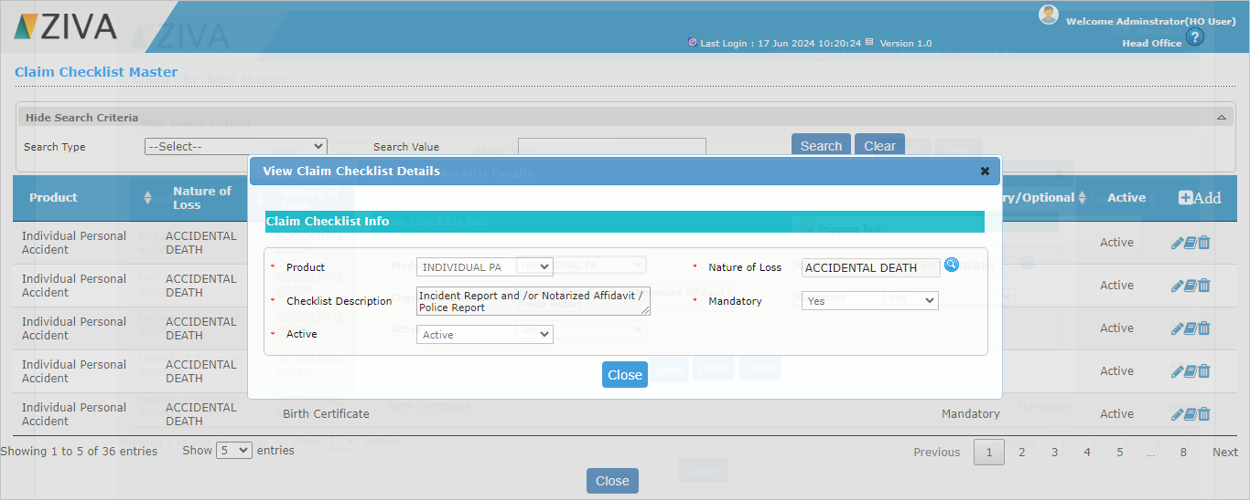

- Click on the Delete button to Activate / Deactivate the existing record.
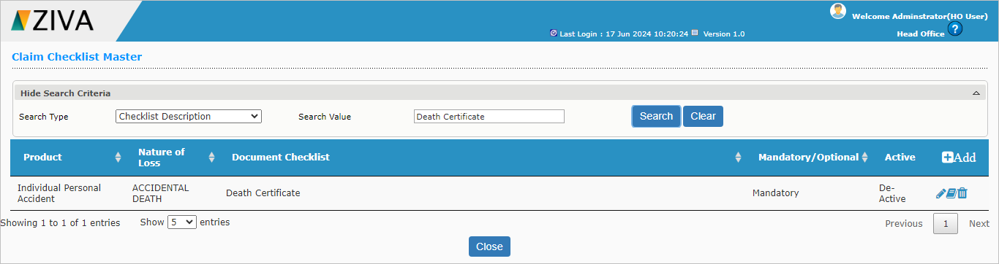

Click on close button to close the window.

